**DB PROJECT REPORT**

***Submitted to Ms Hajra Ahmad & Sir Amin Sadiq***



**Group Members:**

**Noor Fatima (20K-0406)  
Eisha Fatima (20K-0383)  
Bismah Akram(20K-0449)**

**BCS-5D**

**Department of Computer Science**

**National University of Computer and Emerging Sciences-FAST**

**Karachi Campus**

**FASHION STORE**

**INTRODUCTION**

This project is part of our Database Course, we chose to design an ecommerce website on fashion store using our concepts of database studied throughout this semester.

The main aim of “Fashion Store” website is to cut the convenience of the user while shopping the products in shopping complexes. This online fashion shopping helps the user to shop fashion products online so that the user not need to move for shopping. The site is attractive and user friendly so that any new user to the site, easy to purchase the product. There are two types of users available, first is the customer user and the second one is admin. Customer users have limited access right to the system, while the admin users have full control over the system. We have used PHP for main logic, MYSQL as a database, HTML for structure designing and CSS for web page formatting.

**METHODOLOGY**

In this project, we have used HTM, CSS and JavaScript for front end and PHP and MYSQL for backend

1. HTML: HTML is a syntax used to format a text document on the web.
2. CSS(Cascading Style Sheets): CSS is a style sheet language used for describing the look and formatting of a document written in a markup language.
3. JavaScript: JS is a dynamic computer programming language. It is most commonly used as part of web browsers, whose implementations allow client-side scripts to interact with the user, control the browser, communicate asynchronously, and alter the document content that is displayed
4. PHP: Hypertext Preprocessor (PHP) is a technology that allows software developers to create dynamically generated web pages, in HTML, XML, or other document types, as per client request. PHP is open source software.
5. MySQL: MySql is a database, widely used for accessing querying, updating, and managing data in databases.

**DATABASE**

Databases are the storehouses of data used in the software systems. Thedata is stored in tables inside the database. Several tables arecreated for the manipulation of the data for the system. Two essentialsettings for a database are:

* Primary Key- the field that is unique for all the record occurrences
* Foreign Key-the field used to set relation between tables.

Normalization is a technique to avoid redundancy in the tables which is also used in our project.

**MODULE DESCRIPTION**

This project “Fashion Store” is utilized by the online customers for easy shopping of the goods in various verities in the quick manner; it consists of following modules;

**Home:**

Home page is the initial page for website and it shows about what’s on our Fashion shop and it contains home, account, product, cart and wishlist

**Account:**

* Admin: The admin plays a vital role in the Fashion shop and the admin controls the entire database. The main role of the admin is to safeguard the database and can add, delete and update the products from the database. An admin can login into the account and view the products.
* User: Here all the products are displayed. Users can select the product and add the item to the cart or wishlist. A user can also login and register into the account

**Product:**

Product page displays all the products which can be added to the cart and wishlist. User can view the list of products based on their names after successful login. A detailed description of a particular product with product name products details, product image, price can be viewed by users.

**Cart:**

The user can add the desired product into his cart by clicking add to cart option on the product. He can view his cart by clicking on the view order details. All products added by cart can be viewed in the cart. User can remove an item from the cart by clicking remove.

**Wishlist:**

This page will display all the desired products saved by the users to their account, signifying interest without immediate intent to purchase.

**Review:**

Here, users can give their reviews regarding products through ratings and comments to give other users clear idea of the product before purchasing it.

**FUNCTIONAL REQUIREMENTS**

**USER:**

* **USER LOGIN**

**Description of feature:**

This feature used by the user to login into system. A user must loginwith his user name and password to the system after registration. If theyare invalid, the user not allowed to enter the system.

**Functional requirement:**

* Username and password will be provided after user registration is confirmed.
* Password should be hidden from others while typing it in the field
* **REGISTER NEW USER**

**Description of feature:**

A new user will have to register in the system by providing essential details in order to view the products in the system

**Functional requirement:**

* System must be able to verify and validate information.
* The system must require the password of the customer to provide security.
* **PURCHASING AN ITEM**

**Description of feature:**

The user can add the desired product into his cart by clicking add to cart option on the product. He can view his cart by clicking on the cartbutton. All products added by cart can be viewed in the cart. User can remove an item from the cart by clicking remove. After confirming the items in the car tthe user can save the cart and proceed further to payment. On successful order placement, the cart will become empty.

**Functional requirement:**

System must ensure that, only a registered user can purchase items.

**ADMIN:**

* **MANAGE PRODUCTS**

**Description of feature:**

The administrator can add product, delete product, update product and view product

**Functional requirements:**

The system must identify the login of the admin.

**TOOLS**

The tools we have utilized are as follows:

● Visual Studio Code

● XAMPP server

**TABLES**

**cart**

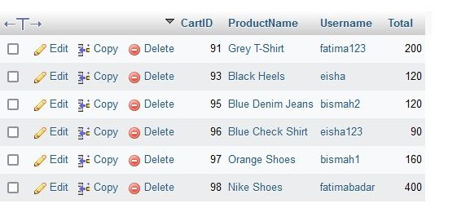

**wishlist**

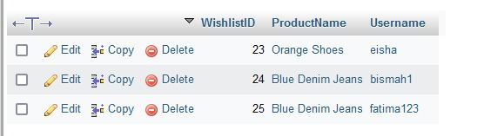

**orderdetails**

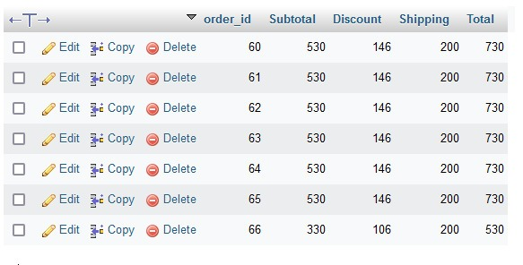

**productdetails**

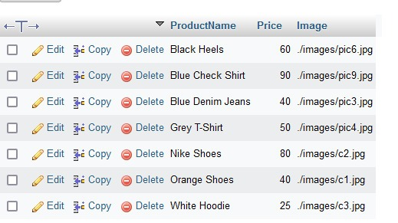

**products**

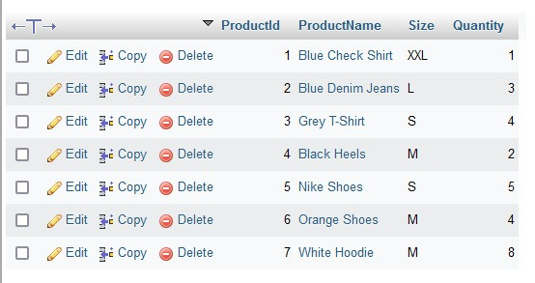

**reviews**

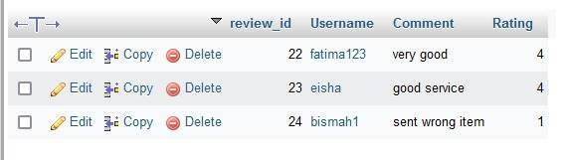

**user**

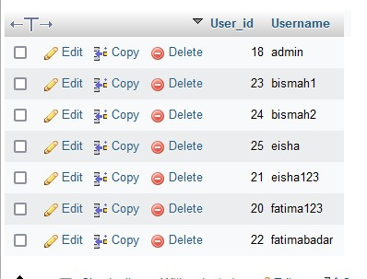

**userdetails**

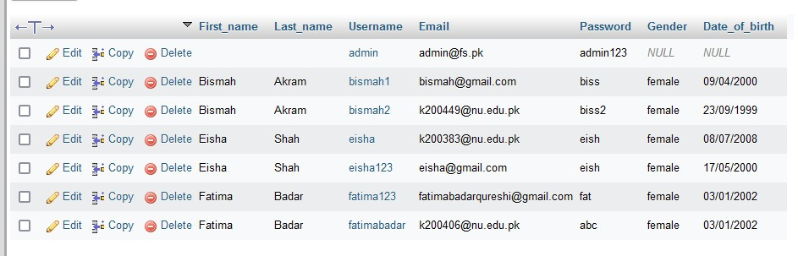

**NORMALIZATION**

**Products**

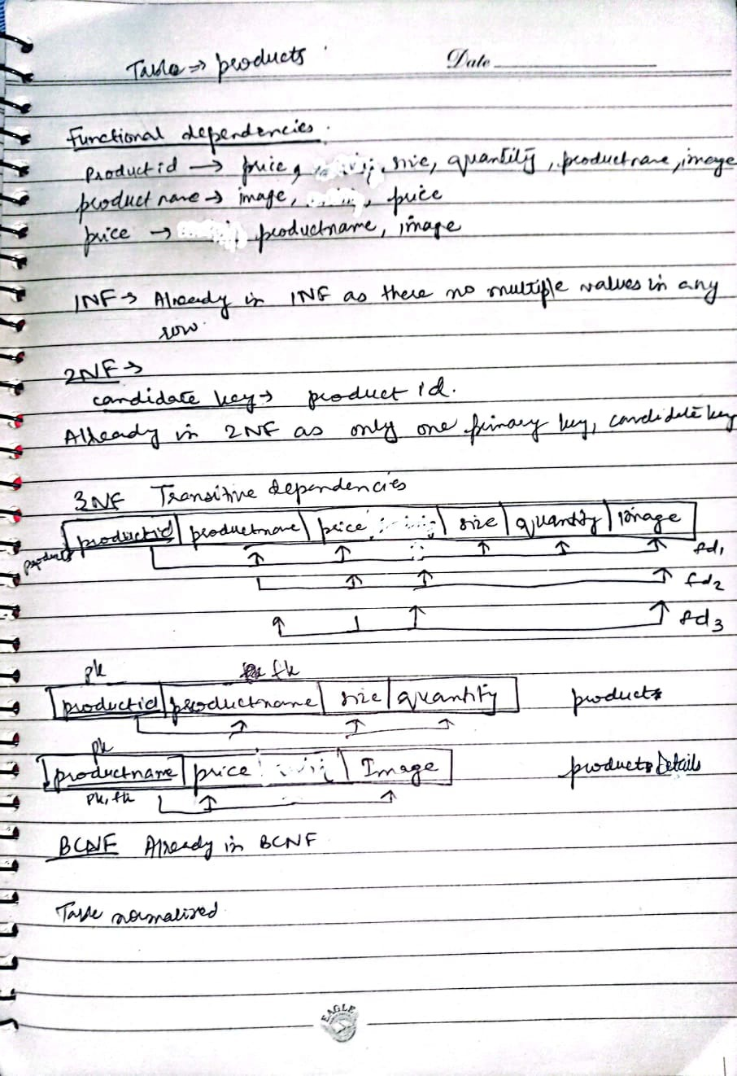

Cart

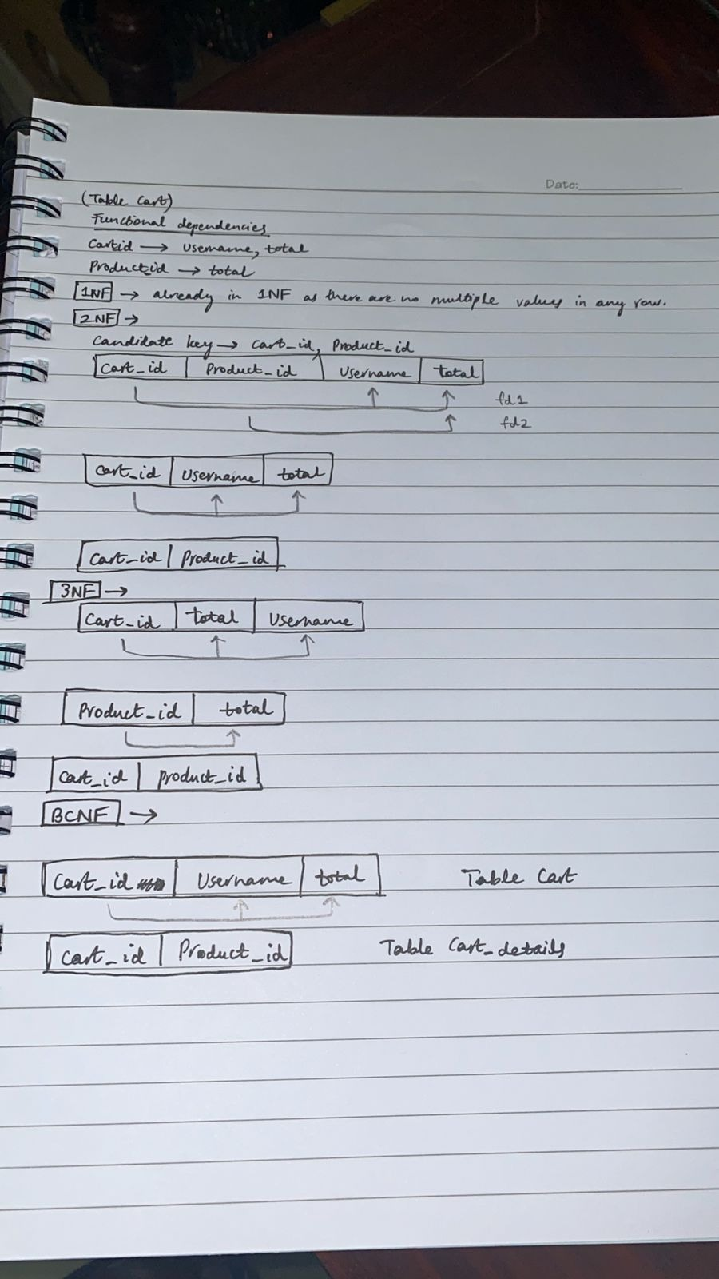

**Order**

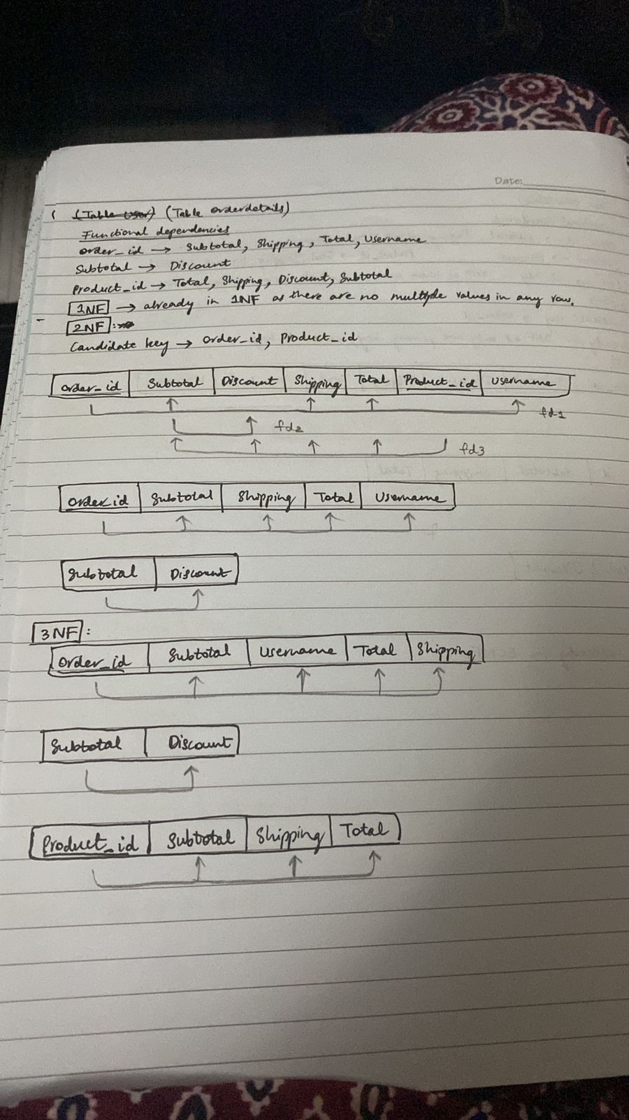

**Users**

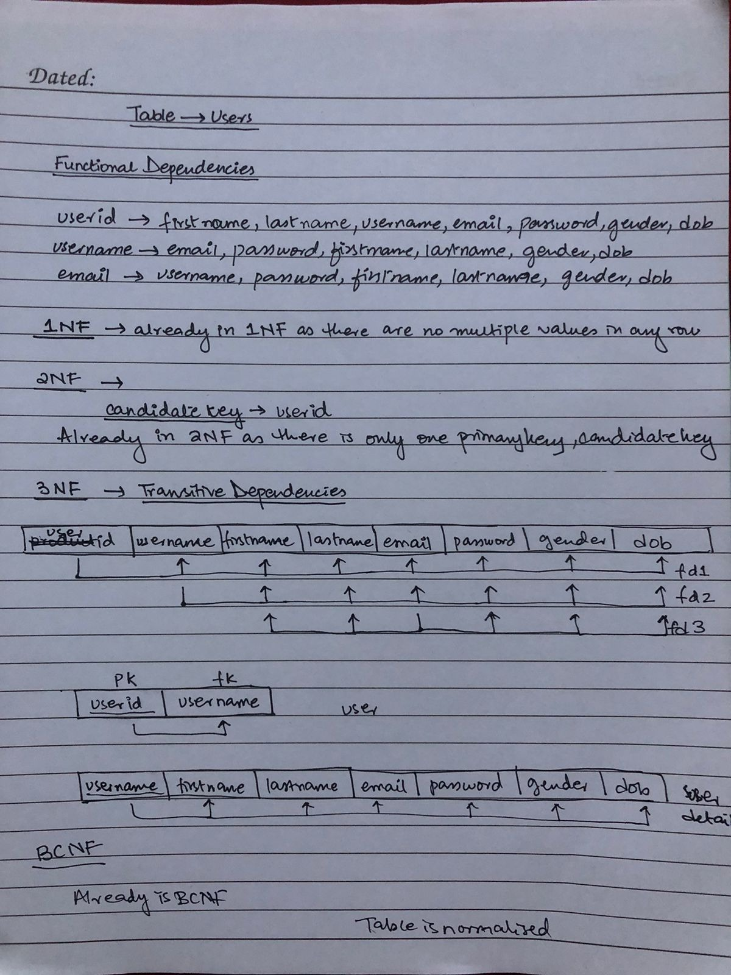

Rest of the tables are already normalized.

**FRONTEND**

**Home page before login**

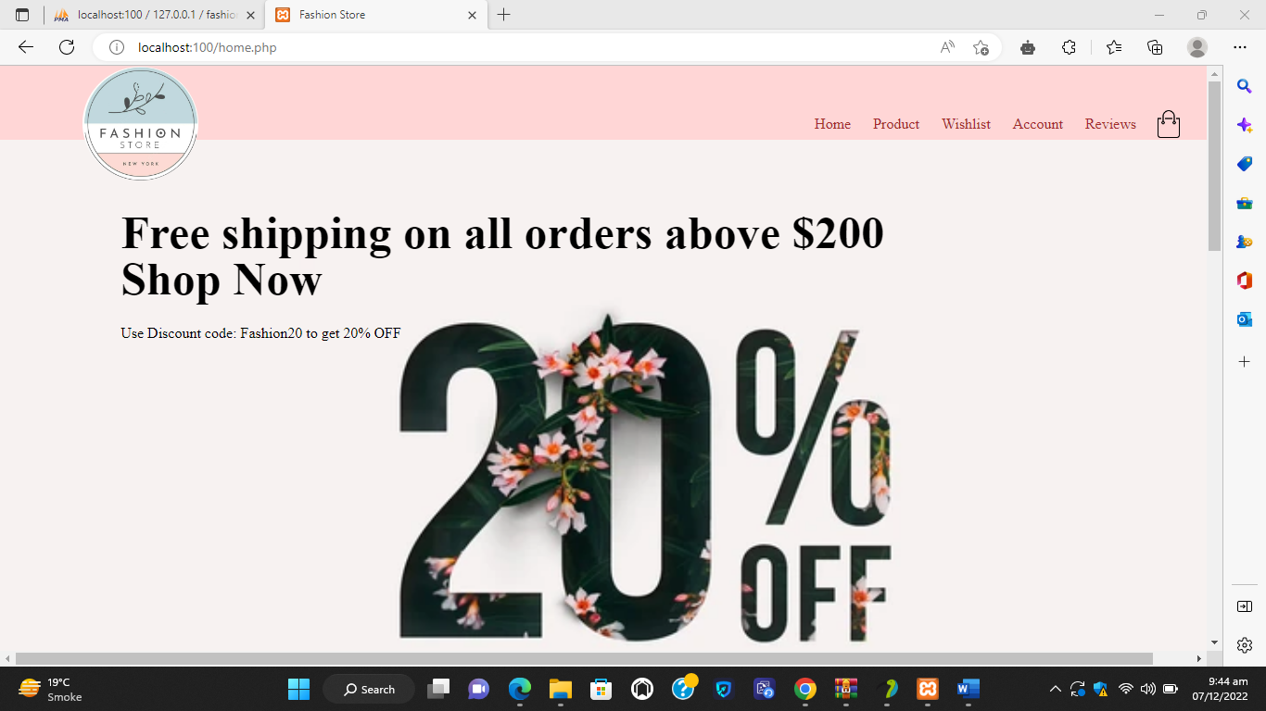

**Account page**

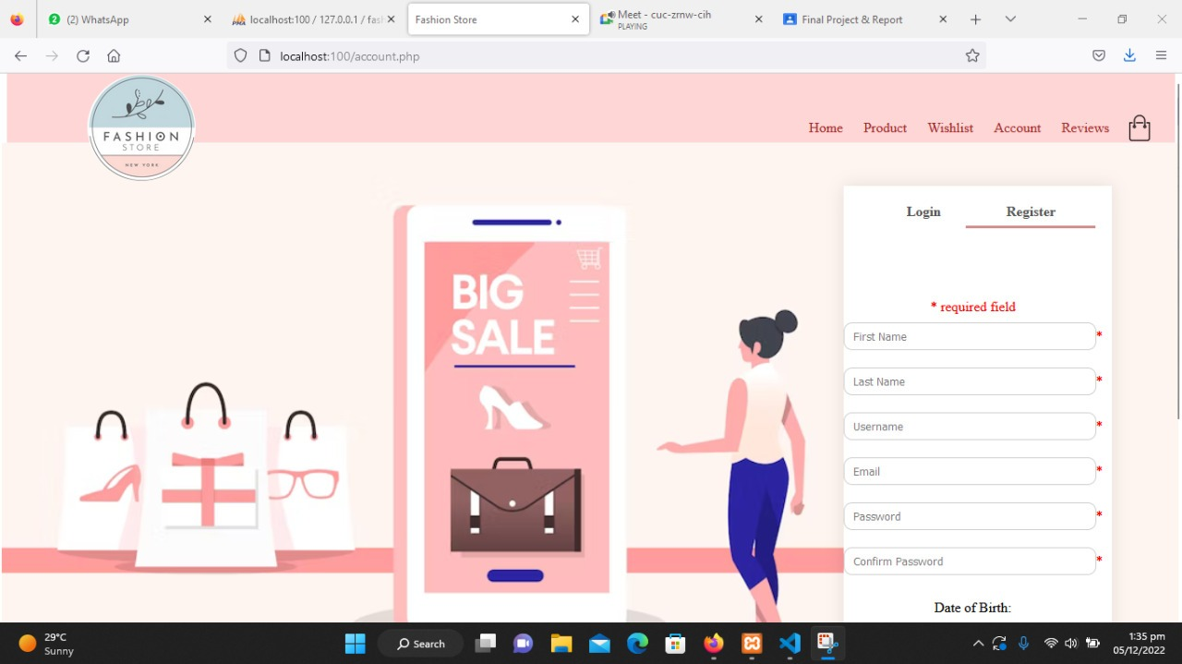

**Register**

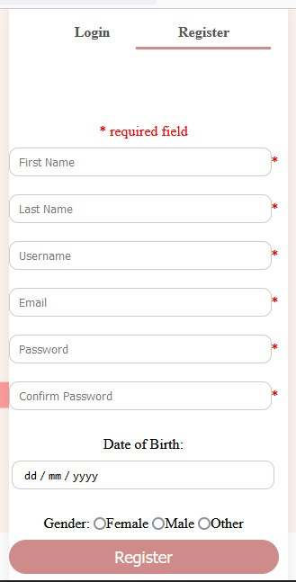

**Login**

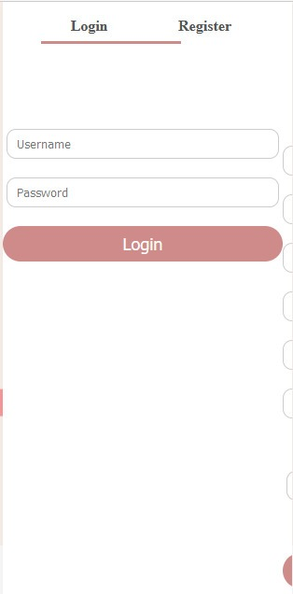

**Product details**

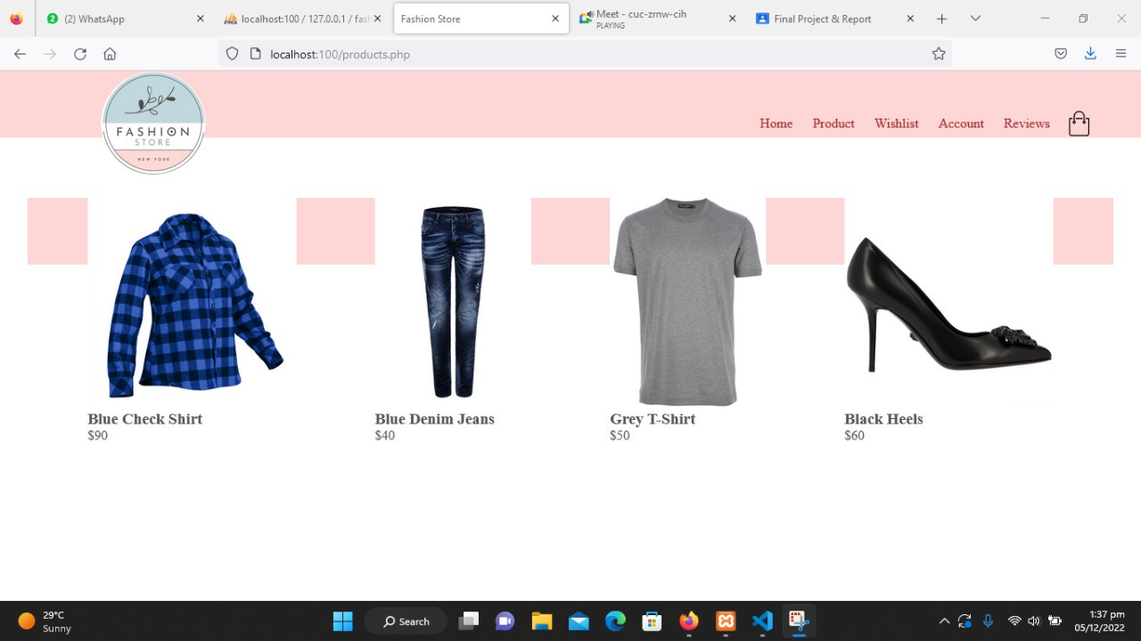

**Product details**

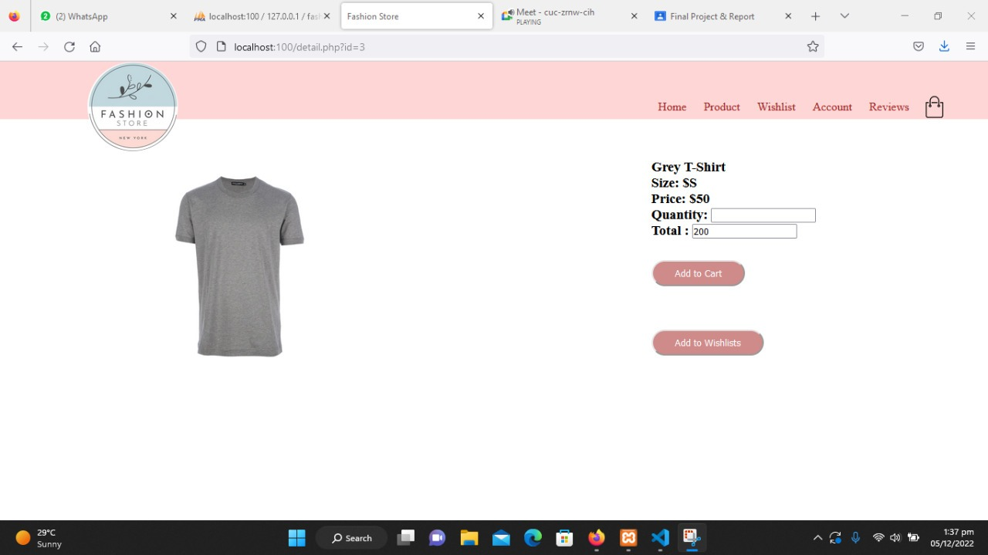

**Wishlist**

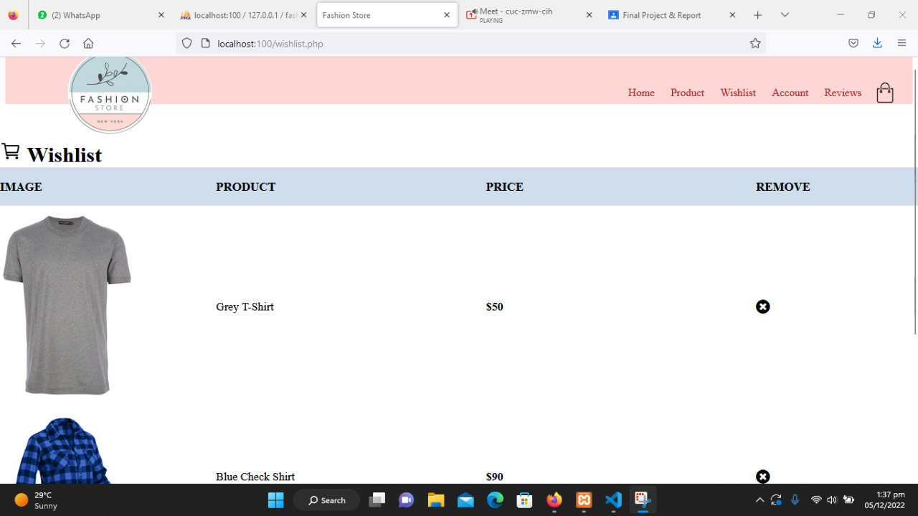

**Shopping cart**

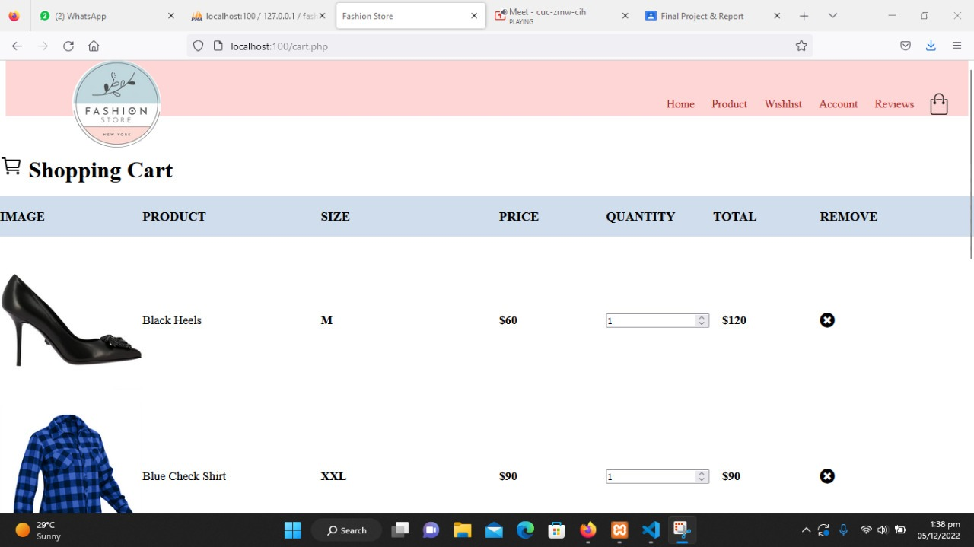

Reviews

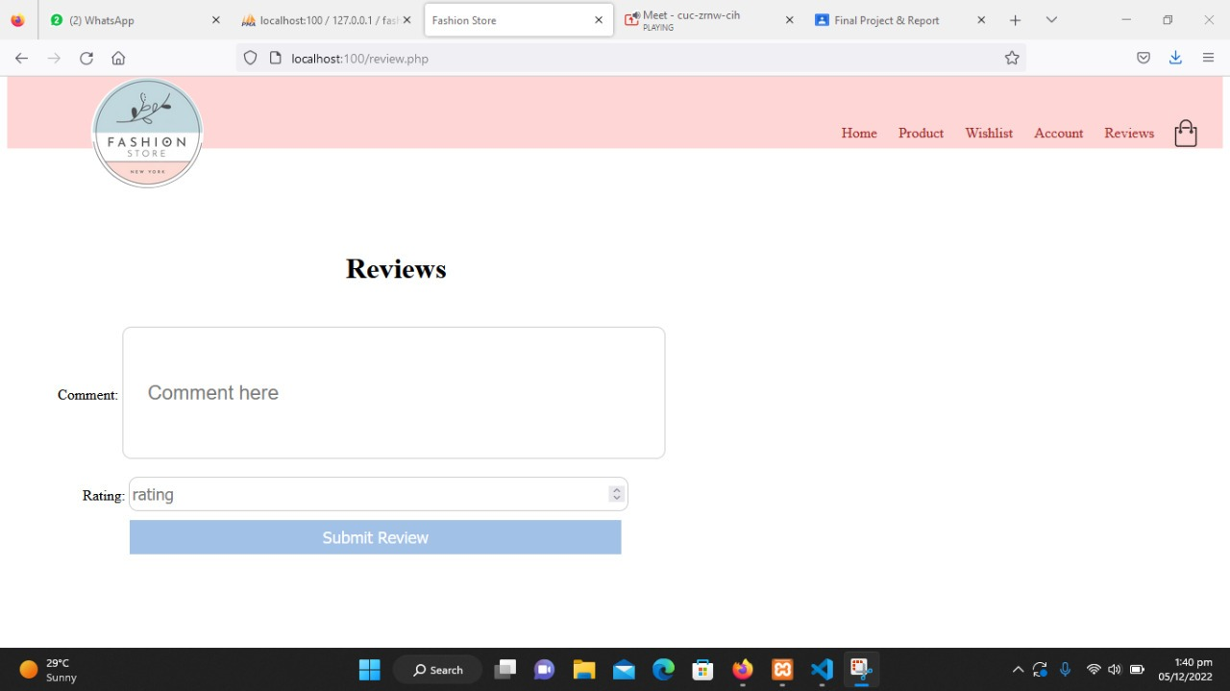

Home page for admin

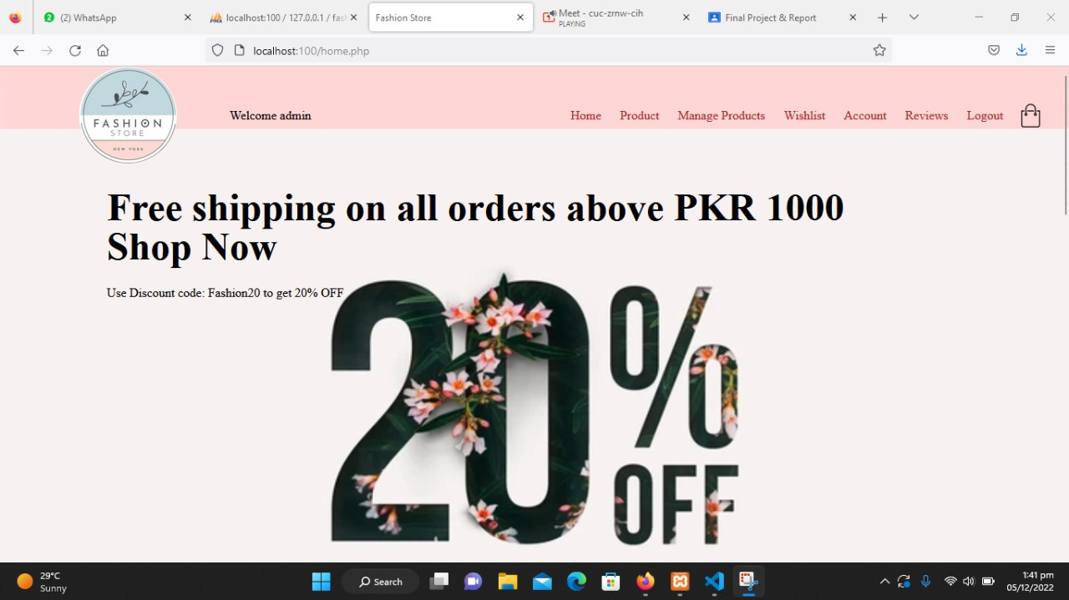

Manage products

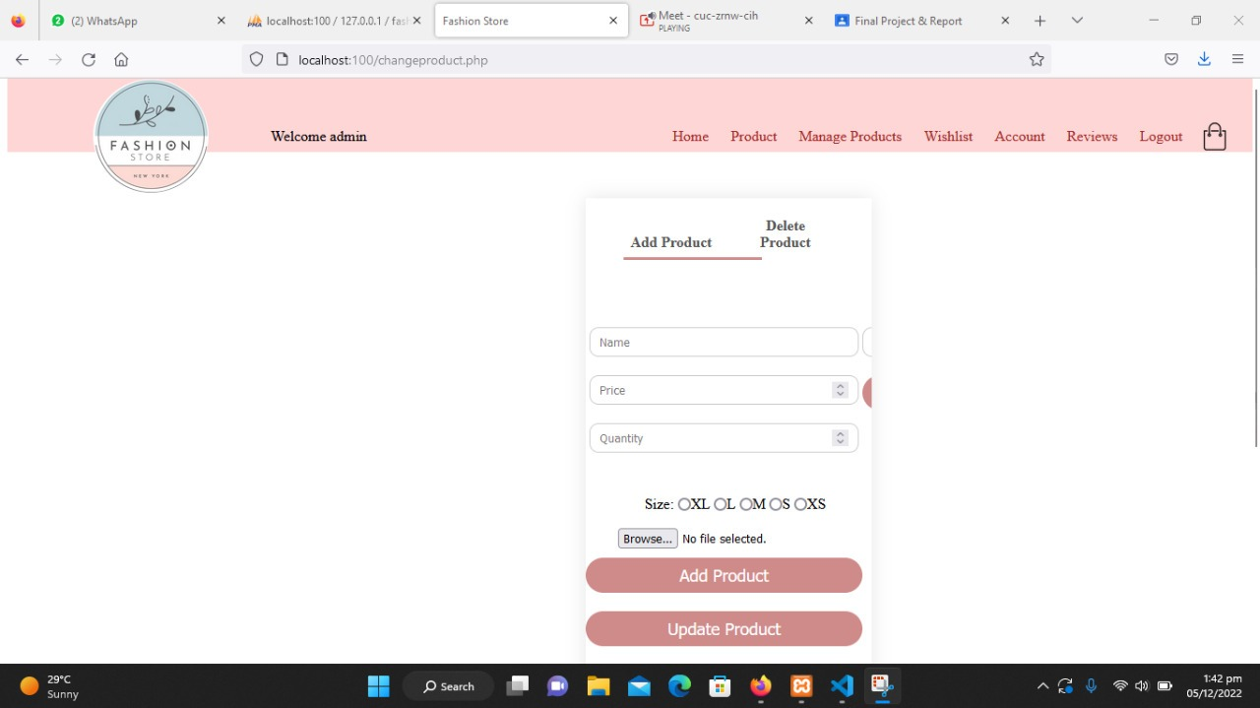

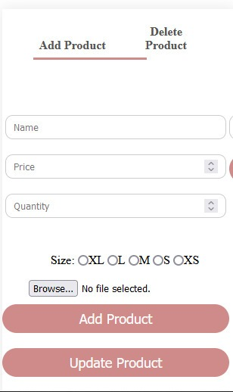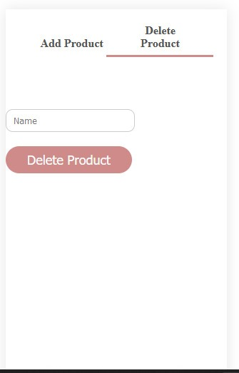

ER DIAGRAM

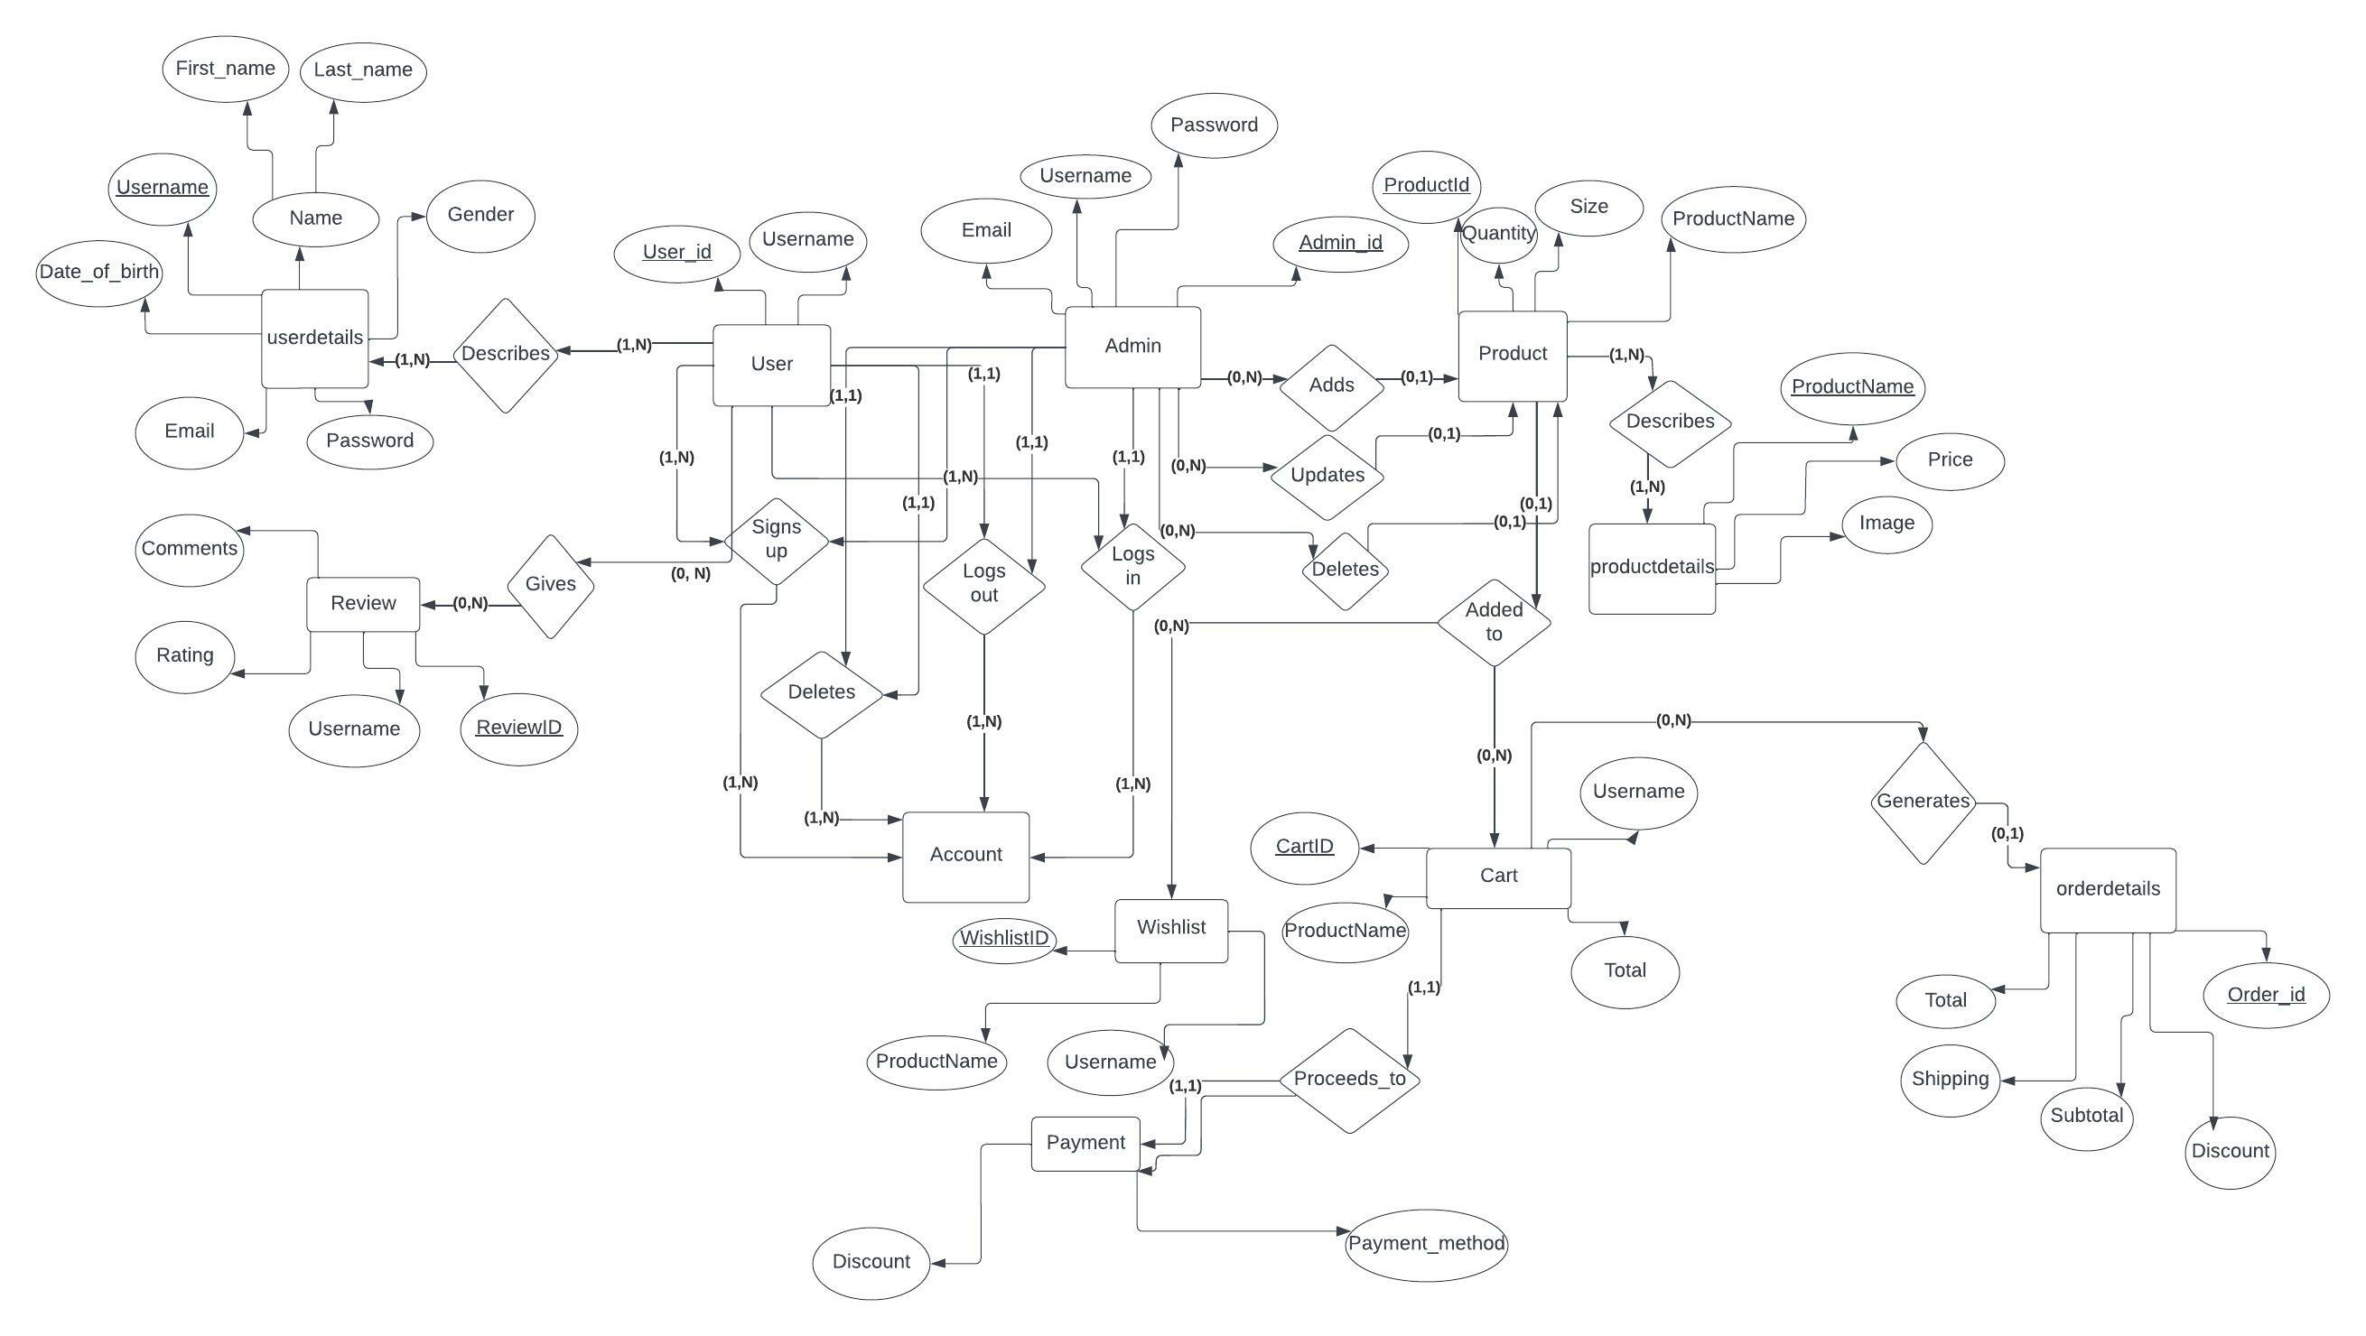

**CONCLUSION**

In conclusion, this project has given us great satisfaction in having designed a website which can be implemented to any nearby shops or branded shops selling various kinds of products by simple modifications. It helped us in gaining valuable information and practical knowledge on several topics like designing web pages using html &css, usage and management of database using php and mysql. The entire system is secured. Also the project helped us understanding about the development phases of a project and software development life cycle. We learned how to test different features of a project and completed our Fashion Store project successfully.